Zoom Email engagement:

Zoom email engagement need “Zoom contact center premium” license.

Connecting to an email account

1. Navigate to Contact Center Management > Preferences menu option

2. Click on the Email Engagements section

3. Click the Connect New Email button to add an email address that will receive emails into the Contact Center

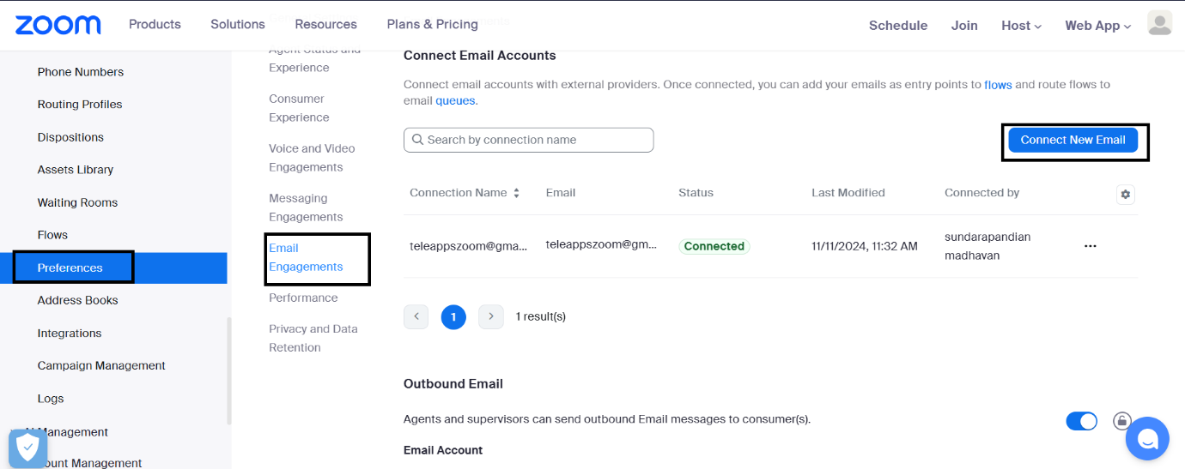

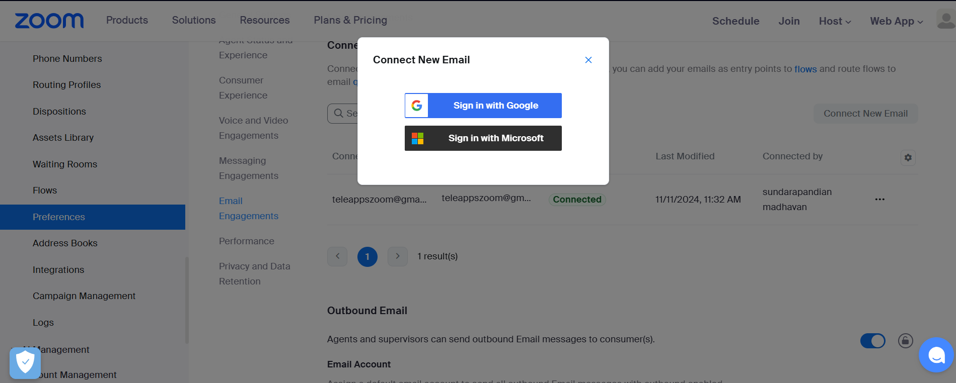

We need use either “Google or Microsoft” zoom not support to integrate with any other email provider

Select your gmail account and mentioned the connection name and Sender name

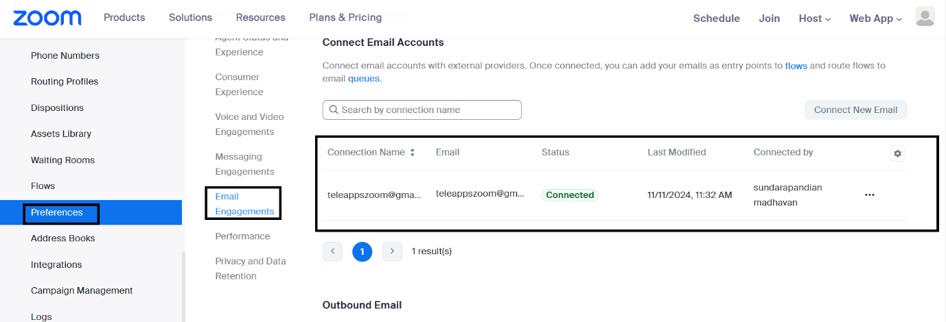

Now that we have learned how Zoom Contact Center connects to the email provider, let’s complete the queue and flow configuration

Provision an Email Queue

We have previously created the video and messaging channels. Now, let’s walk through similar configurations to support the email channel.

1. Navigate to Contact Center Management > Queues

2. Click the Add Queue button

3. Fill out the Add Queue page as described below and click the Save button

a. Name: General Email

b. Channel Type: Select the Email option from the dropdown

4. The page will refresh and the new email queue will be created. Review the settings on the page

5. Locate the Assigned Users section at the top and click the + Add Users link. Add your pre-configured contact center agent (Sundarapandian) to this new queue. Also add your pre-configured supervisor (Bharath.E) as a supervisor.

6. Scroll down to the Email signature section. The Email signature feature can be standardized and supports the use of variables. Create a signature and use the variables to populate the agent’s first name (do this by clicking on Insert Dynamic Field)

7. Click Save Signature

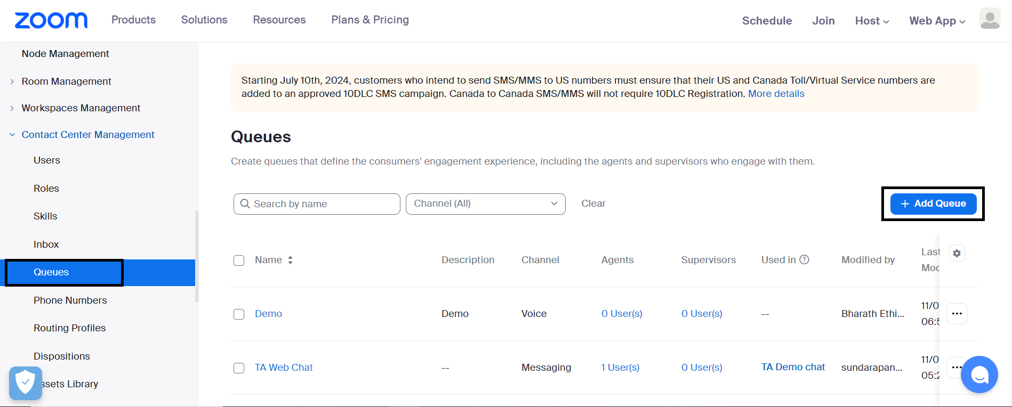

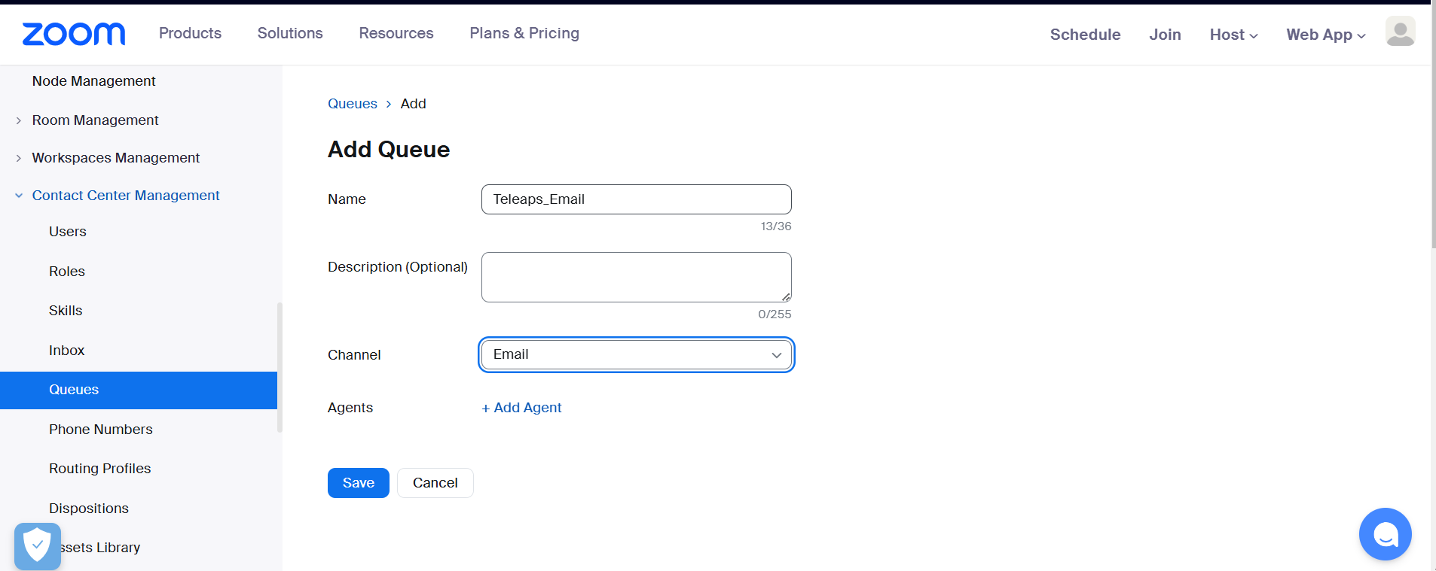

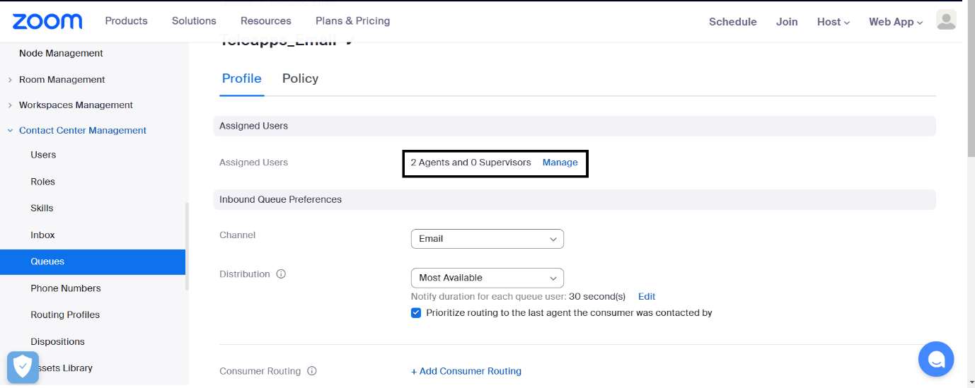

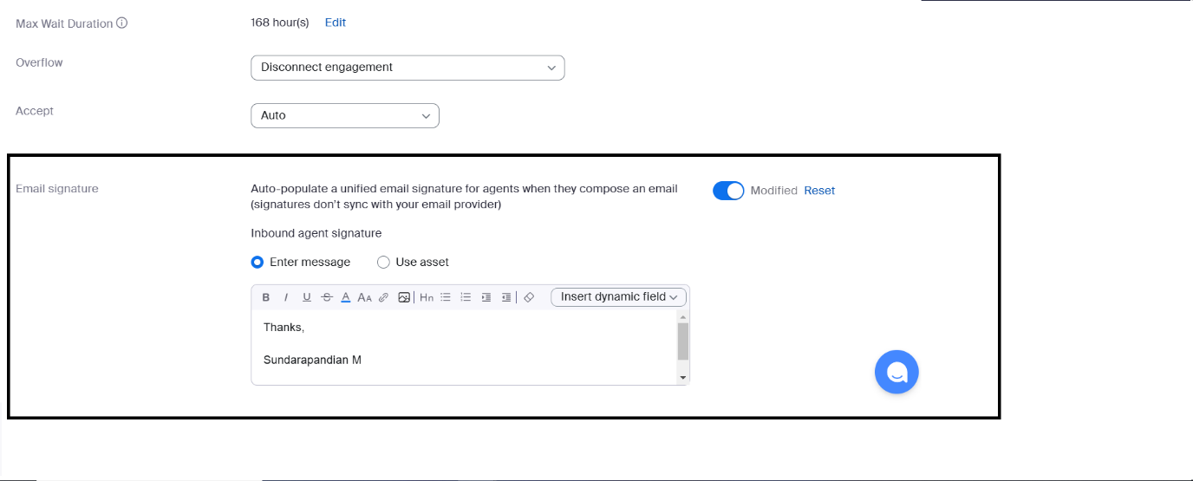

Create an Email Flow

1. Navigate to Contact Center Management > Flows menu option

2. Click the Add Flow button

3. Fill out the Add Flow page and described below a. Channel: Select the Email option b. Name: General Email

4. Click Add to create a new Flow.

5. The Flow Editor will open in a new tab.

6. Lets create a simple email flow that routes an email directly into the queue. Find and drag the Route To widget into your flow. On the Route To widget, ensure that it routes callers to the email queue you just created. Your Flow should look similar to the one shown below.

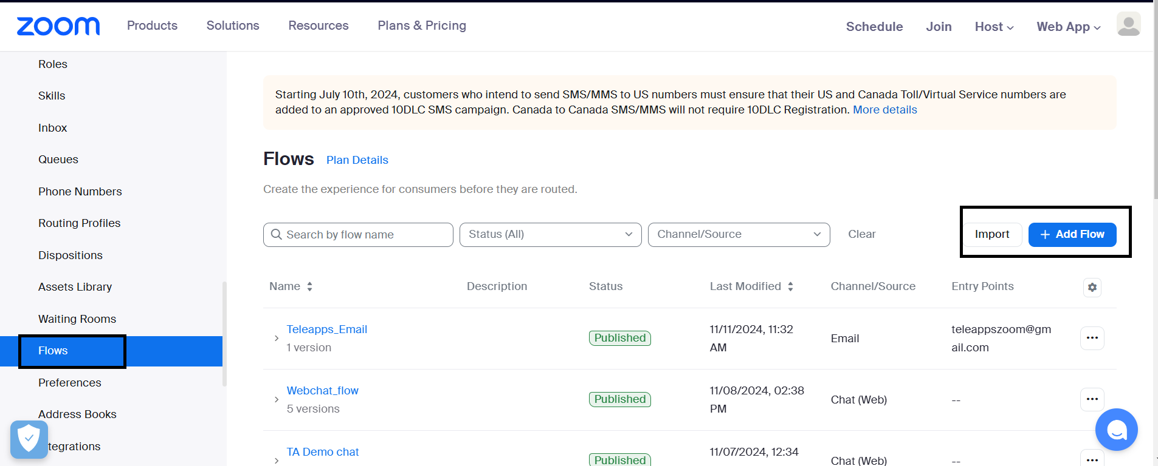

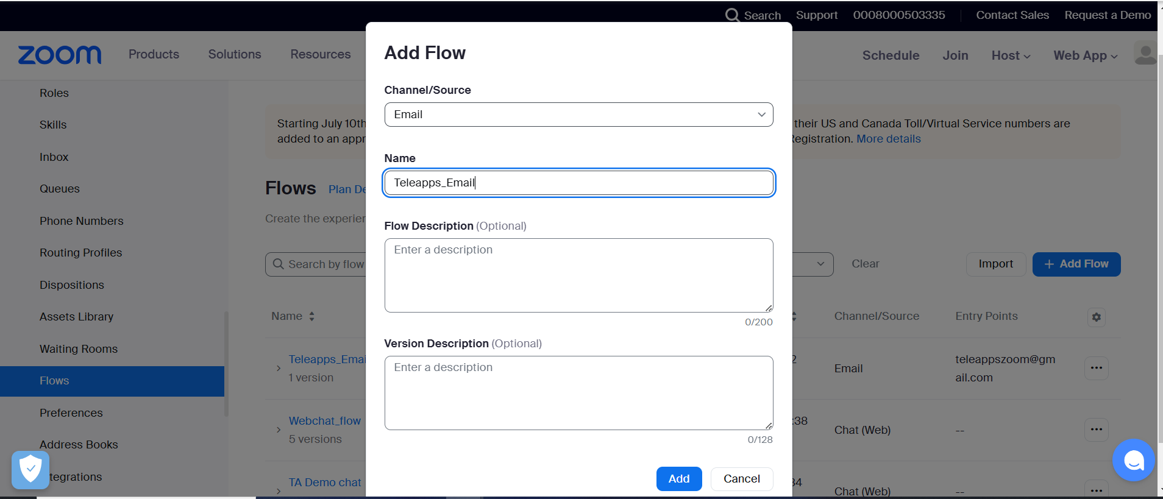

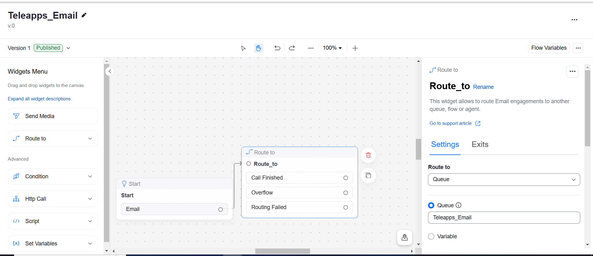

7. Click Save and then Publish

8. Click on the Start widget, then in the popup window click Manage Entry Point followed by + Add Entry Point

9. Select your email address by clicking the check mark, then click Add

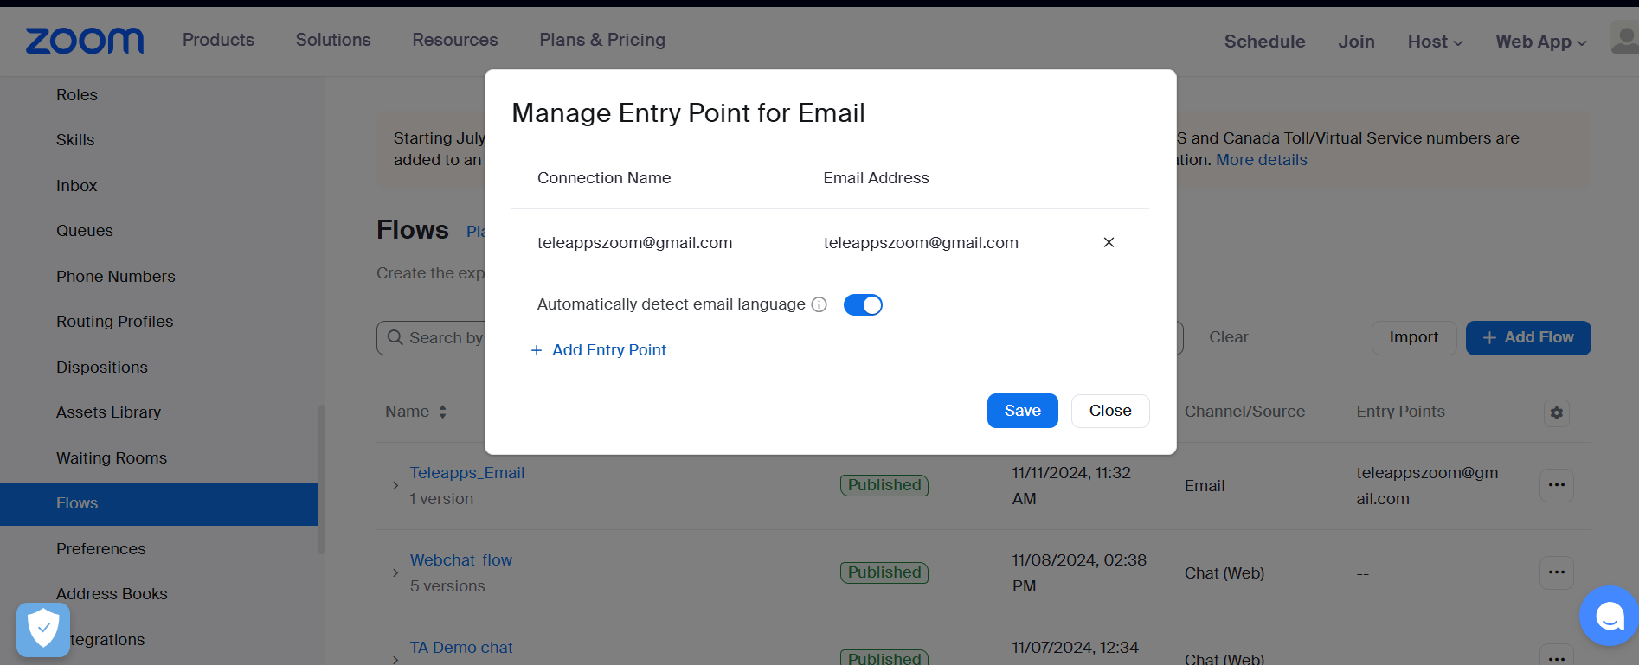

Handling Email engagements When an email is sent to the email address configured in ZCC, the email is routed to the Flow, then to the Queue, and then to an available agent. Let’s send some emails and test this channel.

1. Log in to the Zoom desktop client as your pre-configured agent (Sundarapandian)

2. Click on the Contact Center button on the top of the Zoom client, then click the Start button if you are prompted to start your Work Session.

3. Make sure you are set to Ready on the bottom left hand side of the client.

4. Using your own email (or you can use the user’s Zoom Mail if you’d prefer), send a new email message to the email address configured in Zoom Contact Center. If you need that email address, you can find it in Contact Center Management > Preferences > Email Engagements.

